# [What are the best fruits?] Site Plan

## [Hunter Smith]

## WDD 130

## Overview

### Purpose

[This is a website where anybody can submit their own rankings of what the best fruits are. There will be a main page that shows all of the fruit options and some information about each of them. There’s 2 child pages, one that is a submission page where website visitors can create a custom ranking of some fruits and a description of why they rank it as is, and another page that shows some recent fruit rankings that other people have submitted]

### Audience

[Anybody really, but mostly those who enjoy eating any & all fruits, or at least a large majority of them.]

## Branding

### Website Logo

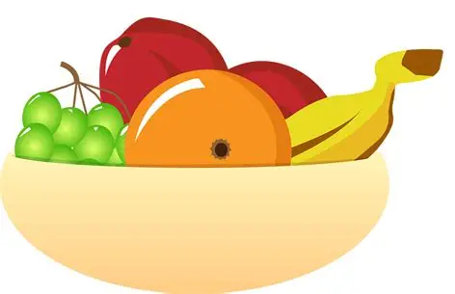

## Style Guide

### Color Palette

| **Primary** | **Secondary** | **Accent 1** | **Accent 2** |
| --- | --- | --- | --- |
| #CB3231 | #FAD201 | #00BB2D | #1C4E8E |

### Typography

#### Heading Font: [Merriweather]

#### Paragraph Font: [Playfair Display]

### Navigation

Home Submissions Other’s Rankings

**Content**

[put all content for the pages here, including written text and images]

(Disclaimer: there will be no footer)

*(page 1)*

What are the best fruits?

This is a website where everybody can discuss or share what they think are the best fruits. On this page you can see some of the options we have for fruits to input into your ranking, and on our submissions page you can create your own ranking to be sent to the internet. You can also look at the “other rankings” page to see other rankings that have been submitted by other users who visited this site.

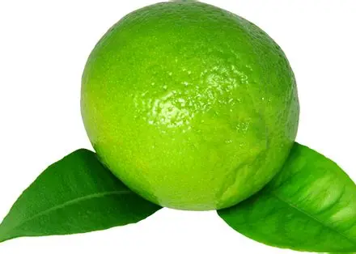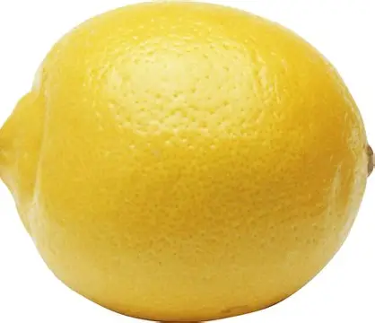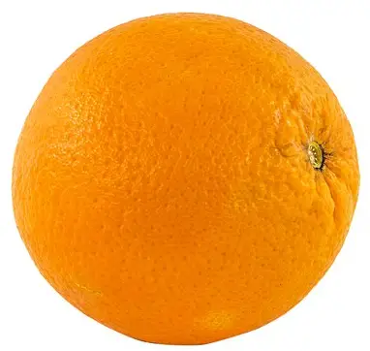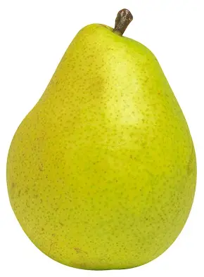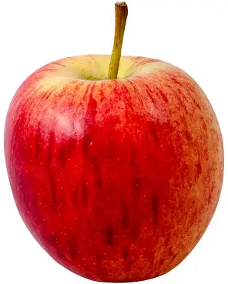

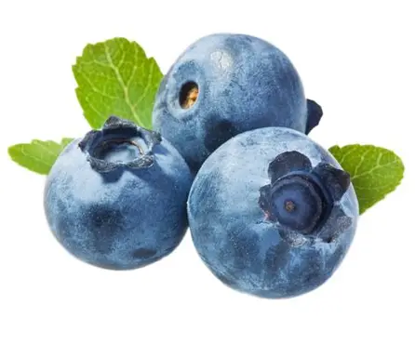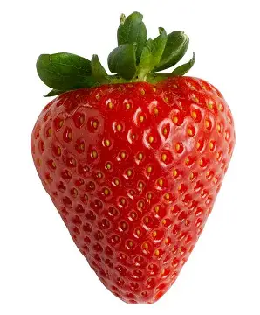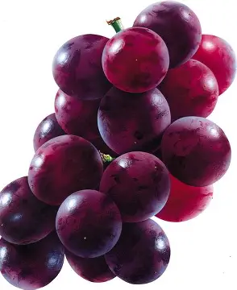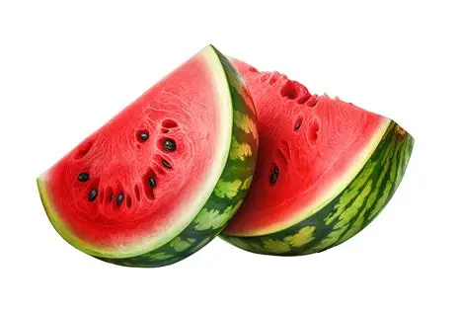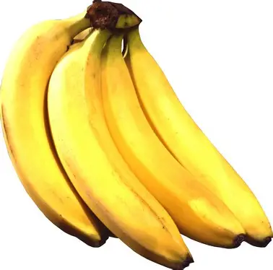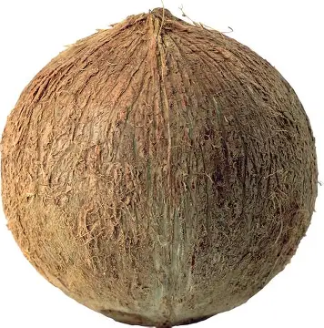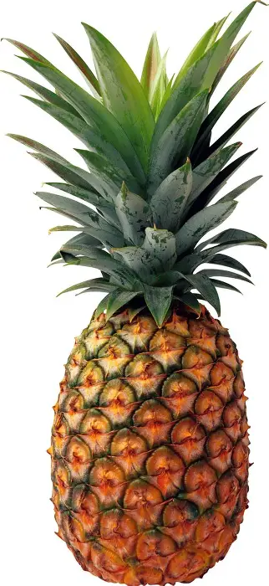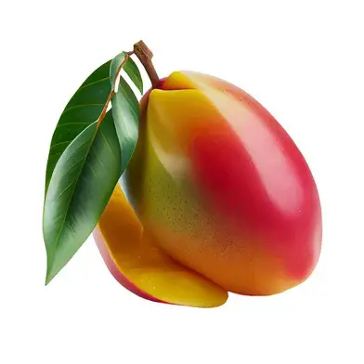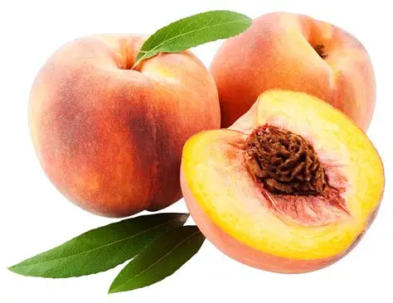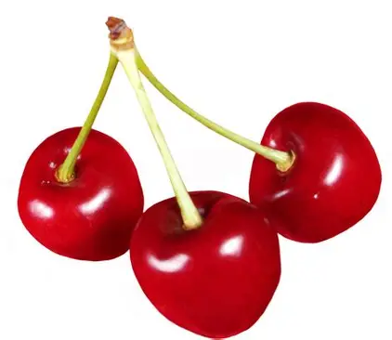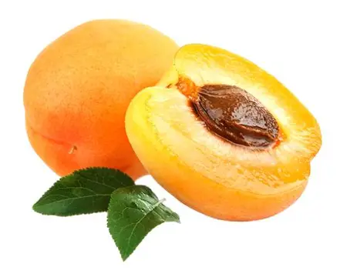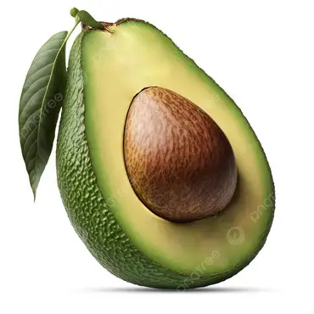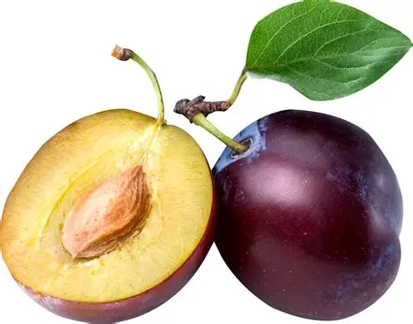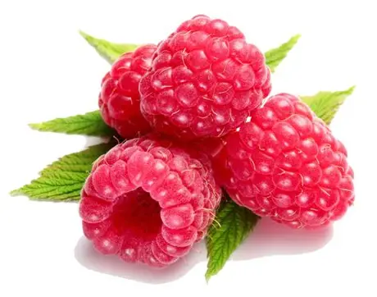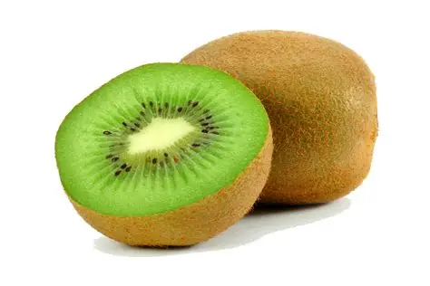

**Apple -** There are over 7,500 different types of apple “cultivars”, or variations.

**Pear -** Pears actually originate from the “rose” plant family.

**Orange -** One of the few existing “things” in the world whose color is also its name.

**Lemon -** Eating lemons may actually decrease your likelihood of receiving life-threatening sickness.

**Lime -** Limes are very high in vitamin C.

**Banana -** Although a banana might become gross after turning brown, it is a good time to use them as banana bread if it reaches that state.

**Watermelon -** The largest grown watermelon weighs up to 350 pounds.

**Grapes -** Grapes have been cultivated for over 8,000 years.

**Strawberry -** Strawberries are made up about 91% water.

**Blueberries -** Blueberries are one of the only foods that are naturally blue.

**Cherries -** Cherries contain melatonin which makes them good foods to regulate sleep patterns.

**Peach -** In some cultures, the peach is considered a symbol of good luck, happiness, & prosperity.

**Mango -** Mangoes are sometimes referred to as “The King of Fruits”.

**Pineapple -** Despite its name this fruit does not fall in the category of a “pine” or an “apple” but is instead considered a berry.

**Coconut -** This fruit is not considered a “true nut” but instead as a “drupe” based on its biology.

**Kiwi -** This fruit shares the same name as a bird, but they are not related at all.

**Raspberry -** A singular raspberry is made up of 100 tiny “druplets” that each have a seed.

**Plum -** Plums can aid in weight loss by being one of the foods that tricks the consumer into feeling full.

**Avocado -** It’s very popular to mistake an avocado as a vegetable, but it is actually a berry.

**Apricot -** Apricot wood is prized for being used to make musical instruments & some furniture.

*(page 2)*

**What is the 20th best fruit?**

Write your explanation on why you think that!

**What is the 19th best fruit?**

Write your explanation on why you think that!

**What is the 18th best fruit?**

Write your explanation on why you think that!

**What is the 17th best fruit?**

Write your explanation on why you think that!

**What is the 16th best fruit?**

Write your explanation on why you think that!

**What is the 15th best fruit?**

Write your explanation on why you think that!

**What is the 14th best fruit?**

Write your explanation on why you think that!

**What is the 13th best fruit?**

Write your explanation on why you think that!

**What is the 12th best fruit?**

Write your explanation on why you think that!

**What is the 11th best fruit?**

Write your explanation on why you think that!

**What is the 10th best fruit?**

Write your explanation on why you think that!

**What is the 9th best fruit?**

Write your explanation on why you think that!

**What is the 8th best fruit?**

Write your explanation on why you think that!

**What is the 7th best fruit?**

Write your explanation on why you think that!

**What is the 6th best fruit?**

Write your explanation on why you think that!

**What is the 5th best fruit?**

Write your explanation on why you think that!

**What is the 4th best fruit?**

Write your explanation on why you think that!

**What is the 3rd best fruit?**

Write your explanation on why you think that!

**What is the 2nd best fruit?**

Write your explanation on why you think that!

**What is the best fruit?**

Write your explanation on why you think that!

When you’ve got your entire ranking done, press this button to submit:

(Submit)

*(page 3)*

On this page, you can see some of the other choices in fruit rankings of other people who visited this site! You can press this button on the right to randomize the ranking that shows up, and they give a detailed explanation as to why it’s ranked like that!

(Randomize)

What did you pick as the 20th best fruit?

(Their explanation as to why)

What did you pick as the 19th best fruit?

(Their explanation as to why)

What did you pick as the 18th best fruit?

(Their explanation as to why)

What did you pick as the 17th best fruit?

(Their explanation as to why)

What did you pick as the 16th best fruit?

(Their explanation as to why)

What did you pick as the 15th best fruit?

(Their explanation as to why)

What did you pick as the 14th best fruit?

(Their explanation as to why)

What did you pick as the 13th best fruit?

(Their explanation as to why)

What did you pick as the 12th best fruit?

What did you pick as the 11th best fruit?

(Their explanation as to why)

What did you pick as the 10th best fruit?

(Their explanation as to why)

What did you pick as the 9th best fruit?

(Their explanation as to why)

What did you pick as the 8th best fruit?

(Their explanation as to why)

What did you pick as the 7th best fruit?

(Their explanation as to why)

What did you pick as the 6th best fruit?

(Their explanation as to why)

What did you pick as the 5th best fruit?

(Their explanation as to why)

What did you pick as the 4th best fruit?

(Their explanation as to why)

What did you pick as the 3rd best fruit?

(Their explanation as to why)

What did you pick as the 2nd best fruit?

(Their explanation as to why)

What did you pick as the best fruit?

(Their explanation as to why)

**Wireframes**

### Home

